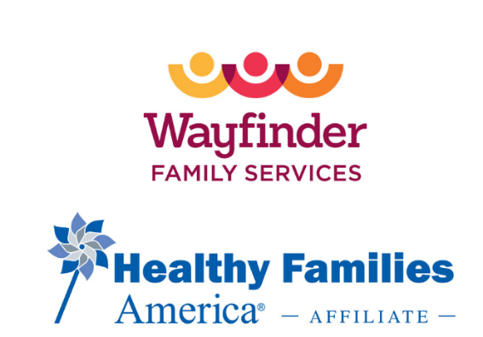
Team Directory
Name | Title | Email Address | Cell Phone # | Supervisor
Dawn Vo-Jutabha, PH.D. | Executive Vice President/Chief Operating Officer | dvo-jutabha@wayfinderfamily.org | (310) 595-5281 | Jay Allen
Diana Lopez-Trujillo | Assistant Director, Child Development Services | DTrujillo@wayfinderfamily.org | 310-903-2292 | Dawn Vo-Jutabha, PH.D.
Karen V Sanchez Alamillo | Program Supervisor of Healthy Families of America | kalamillo@wayfinderfamily.org | 213-815-4729 | Diana Lopez- Trujillo
Yanet Cortez | Family Support Specialist of Healthy Families of America | ycortez@wayfinderfamily.org | 310-995-6632 | Karen V Sanchez Alamillo
Stephanie Espinoza | Family Support Specialist of Healthy Families of America | sespinoza@wayfinderfamily.org | 213-494-0187 | Karen V Sanchez Alamillo
Adriana Mosqueda | Family Support Specialist of Healthy Families of America | amosqueda@wayfinderfamily.org | 213-948-6522 | Karen V Sanchez Alamillo
Celia Fernandez | Family Support Specialist of Healthy Families of America | cfernandez@wayfinderfamily.org | 213-826-4406 | Karen V Sanchez Alamillo
Erin Pakingan | Family Support Specialist of Healthy Families of America | epakingan@wayfinderfamily.org | 323-854-1739 | Karen V Sanchez Alamillo
Marlynne Hernandez | Family Support Specialist of Healthy Families of America | marhernandez@wayfinderfamily.org | 310-743-5437 | Karen V Sanchez Alamillo

